


Assessment Guide

The following assignment will help you prepare for the Cook Systems FastTrack’D Java Program and provide a means for your recruiter to assess your readiness for the training. It is critical for you to have familiarity with the Eclipse editor and basic Java concepts before arriving for your training. You may seek assistance from others (not your recruiter) while you are learning but YOU MUST BE ABLE TO DEMONSTRATE YOUR KNOWLEDGE to us, so make sure whatever assistance you receive does not prevent you from mastering and internalizing these skills for yourself (don’t have someone else do it for you).

After you have completed the assignment or as much of it as you can complete, follow the instructions to export and submit your solution. Continue to review or repeat the assignment until you are confident you are prepared for the most intense and rewarding training experience anywhere. Good luck!

For the following assignment, you are to create a program with a graphical user interface (GUI) that allows for a user to select computer parts from a list and add them to a list representing the computer they wish to build. In order to complete this assignment, you will utilize Swing, Window Builder, and JAXB.

Swing is a GUI framework that comprises Java objects that represents items displayed to a user. Window Builder is a tool that allows you to “drag and drop” Swing components onto an editor, allowing you to organize the layout of your GUI on a presentation level instead of programmatically.

JAXB, Java Architecture for XML Binding, is a tool by which Java objects can be “marshalled” into XML documents and “unmarshalled” back into Java objects. You won't need to worry about how this happens for now, but you do need to know how to annotate a Java class as being compatible with JAXB. This is done by putting the @XMLRootElement annotation above the declaration of a class, i.e. before you declare “public class myClass.”.

Throughout this guide, there are links to external resources such as tutorials. It is imperative that you review these resources and make sure to understand the concepts introduced in this assessment. This assessment will give you a taste of what the FastTrack'd program is like. It is our hope that you will do well and succeed in this program.

Your code must be commented, or your assessment will not be graded.

Eclipse Setup

1. Download Eclipse Luna from the following link.
https://www.eclipse.org/downloads/packages/eclipse-standard-44/lunar
A list of links will be available on the right side of the page. Select the correct one for your operating system.
2. Extract the contents to the folder of your choosing. Afterward, navigate to that folder and open Eclipse.
3. Select your workspace. Your workspace will be the folder that contains all of your Eclipse projects.
4. Next you need to install Window Builder. The following link will guide you through that process. http://download.eclipse.org/windowbuilder/WB/release/R201406251200/4.4/
5. After Window Builder is installed, import the project template that was included with this document.

- Navigate to: File >> Import.
- A window should pop up with import options. Navigate to General and select “Existing Projects into Workspace”. Press the “Next” button.
- At the top of the window, select “Select archive file”. Click on browse and navigate to the .zip file included with this Document. Press the “Open” button.
- Click the “Finish” button.
6. The project template should now appear in your package explorer.

Assessment

1. In the project explorer, open Window.java.
- It is located under src >> com.cooksys.assessment.
- Right click on Window.java and select Open with >> WindowBuilder editor.

2. You should see some generated code from Window Builder. At the very bottom, select the “Design” tab.

3. An editor should be displayed at this point. This is where you will create the layout of the application. Below is a couple of links to help you get familiar with Window Builder and Swing.

- http://www.vogella.com/tutorials/EclipseWindowBuilder/article.html
- http://www.tutorialspoint.com/swing/index.htm

4. Design the window to look similar to this example (Do not worry about the list of PC parts just yet):
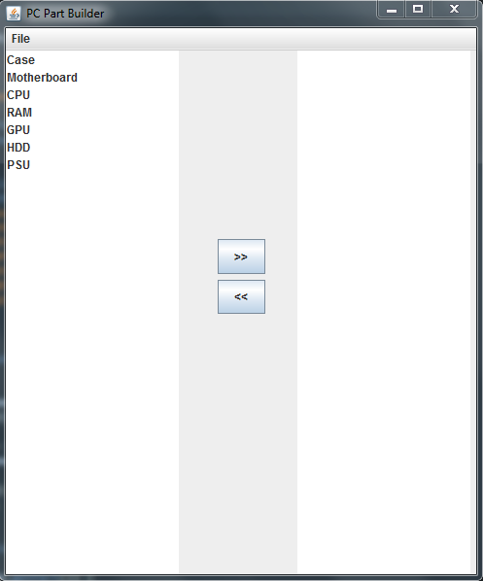

5. Your window should have:

- Menu bar
- File
- Load
- Save
- Exit
- Add button.
- Remove button.
- Two panels that contain a Jlist.

6. After you design the window, click the “Source” tab at the very bottom. You will see that Window Builder has generated a lot more code. Go ahead and run the program and make sure everything looks as it should.

- Click the green play button at the top of Eclipse. A window should appear asking you to select run options. Select “Java Application” and click “Run”.

As long as everything looks the way it should, you're now ready to fill in the blanks.

7. The next thing to do is populate the left panel with a list of computer parts. These are the list of parts the list should contain:

- Case
- Motherboard
- CPU
- GPU
- PSU
- RAM
- HDD

8. The following link provides a tutorial on using and populating Jlists.
http://www.tutorialspoint.com/swing/swing_jlist.htm

9. After you have populated the left panel with a list of parts, run the application and be sure that the list of parts is displaying in the left panel.

10. Next, you need to add events to the buttons on the window.

- In the “Design” view, double-click on the button you created to add parts to the right panel. This will bring you back to the source where it has generated code to handle a button click. This button should add the selected part from the left panel to the list of parts in the right panel.
- The remove button should delete a part from the right panel.
- In your menubar, you will have to right-click on a menu item and select “Add event handler” >> “action” >> “Action performed”. This will generate event handler code for your menu items.
- “Exit” should obviously close the program.

11. Before you write the even handlers for the “Load” and “Save” event handlers, you need to become familiar with JAXB. The following links should get you where you need to be.
XML overview: http://www.w3schools.com/xml/default.asp
JAXB Tutorial: http://www.mkyong.com/java/jaxb-hello-world-example/

12. In the Window class, add a method called save(). This method should marshall the list of computer parts in the right panel to an XML file.

13. Create another method called load(). This should unmarshall the saved XML file back into an object.

14. Using the same process as you did for the Exit menu item, create event handlers for “Save” and “Load”.

- The “Save” event will call your save() method and save the list of parts in the right panel to an XML file.
- The “Load” event should clear the right panel, and call your load() method. When load() is called, it should display the unmarshalled data in the right panel.

15. Run your program and make sure everything functions properly. Your final application should:

- Have a window with a menubar, two panels containing Jlists, and two buttons to add and remove computer parts.
- There should be a “Load”, “Save”, and “Exit” menu items in the menu.
- When you click the add button, it should add the select item from the left panel to the right panel.
- When you click the remove button, it should remove the selected item from the right panel.
- When you click “Save”, it should save the items in the right panel to an XML file.
- When you click “Load”, it should load the saved XML file, and display the list of items in the right panel.
- When you click “Exit”, it should close the application.

16. After you complete the assignment, submit the application

Export the project in zip format. To do this, go to the location of your project, right click on it and select Send to >> Compressed (zipped) folder. Upload the zip file to the assessment submission section of your FastTrack’D Candidate Portal (if you never received your login details, enter the email address you applied with, click “I forgot/lost my password”, then click the Login button. You should receive an email with a temporary password within a few minutes. If you do not receive this email, contact your recruiter).

